
FocusPoint
(COMPANY NAME) Blueprint
DATE


FocusPoint eCommerce Configuration Blueprint
The implementation of FocusPoint eCommerce platform, Customer will implement a standardized integration from SAP Business One to FocusPoint eCommerce for Business to Business (B2B) through SAP’s supported integrations.
Customers will place orders on the FocusPoint store portal using their internet browsers. The store runs on a FocusPoint server and communicates through the SAP Business One integration framework to the product company database to exchange master data and orders.

Integration Overview
The integration synchs master data from Item and Business Partner master data as well as transactional table.

Integration Transaction Overview
Historical data is fetched from the Customer order portal within FocusPoint to retrieve sales documents including Sales Orders, Deliveries, A/R Invoices, A/R Credit Memos, and A/R Return documents for both open and closed status within a timeframe entered by the registered users accessing the customer portal.

FocusPoint Package Summary
Estimated Timeline: X after integration.
FocusPoint Package | Implementation Hour Range
PACKAGE | X
Partner | X
SAP Version | X
Expected Go Live Date | X

        - Requirements for FP Package
Section | Requirements Request / Comments | Included in Subscription | Additional Information
SAP Database | Single or Multiple
Set Up | B2B, B2C or Both
Web Stores | Number of web stores
Configuration | Login –  Contact email on BP master for web enabled.  -web validated contact  -password stored/changed on FocusPoint portal  Error message at failed login (Standard Functionality – no action needed)  Main screen capable of displaying updates/ announcements - Banners, Blogs, News, etc.… -TRAINING  Responsibility of customer to create, maintain topic pages, banners, etc.… (Standard Functionality)
Configuration | What Language(s) will be used on the Site:
Configuration | What Currency will be used on the Site:
Configuration | General Public Navigation –  Can the public navigate the site?  -products  -pricing or no pricing  -add to cart
Configuration | Registration process:  -No registration  -General registration  (Email validate- Send to SAP immediate)  eform registration – custom form emailed to you.  -Guest checkout
Product | Product content such as short, long descriptions will come from SAP B1 in the FP Item Config
Product | Number of Products (all in SAP)
Product | Number of Concurrent users buying (approx..)
Product | How are the products configured:  -1 to 1 Mappings  AND / OR  -Parent/Child (1 product made up of multiple SKUs based off a selection criteria) |  | SAP TRAINING  Example of Parent/Child: Shirt is the parent comes in size Small / Med / Large. These are the children
Product | Item pictures:  -Stored on FocusPoint  OR  -Stored in SAP B1 in the FP Item Config |  | TRAINING
Product | Specifications – will be used, these will come from SAP B1 in the FP Item Config. |  | SAP TRAINING  Are they existing? udf’s (examples: size/dimensions)?
Product | Data Sheets stored in SAP | Yes or No
Product | Related Items will be used:  -Will come from SAP B1 in the FP Item Config | Yes or No
Inventory | Inventory updates from SAP Business One sync’d every 5 minutes on differential for web-enabled items (Standard Functionality – no action needed)
Inventory | Warehouses –  How Many? |  | If yes: Do you want the combined total to show on the site or show separate?
Inventory | Warehouse Code (s):
Inventory | Do you allow Backorders | Yes or No
Inventory | Display Inventory on Website | Yes or No
Inventory | Display in stock message -  -In Stock  -Out of Stock  -Amount in Stock  -ATP showing
Pricing | Configured using customer groups and price lists in SAP Business One? |  | SAP TRAINING
Pricing | Breakdown of pricing structure in SAP. |  | SAP TRAINING
Pricing | Special Prices per Business Partner in SAP Business One? | Yes or No | SAP TRAINING
Pricing | Period and volume discounts? | Yes or No | SAP TRAINING
Customer Roles | Are you using any Brand Restrictions? | Yes or No | SAP TRAINING
Customer Roles | Do you have any Product Restrictions? | Yes or No | SAP TRAINING
Tax | Are customers tax exempt? | Yes or No | SAP TRAINING
Tax | Tax exempt customers set-up in SAP Business One at BP Master? | Yes or No | SAP TRAINING
Tax | Tax by item? | Yes or No | SAP TRAINING
Tax | Taxes Calculated:  -Add On  -Tax list from SAP |  | If tax list from SAP, please provide tax list with codes and percentages
Orders | In FocusPoint we will hide the Web order # and will only display SAP Order # (Standard Functionality – no action needed)  -Re-order from previous order(s)  Single cart –  -Review order in cart before submitting order.  -Order confirmation email – Training  -Provide an order Confirmation Order number/reference
Orders | Customer Edit Billing Address at Checkout: | Yes or No
Orders | Customer Edit Shipping Address at Checkout: | Yes or No
Orders | If Yes:  -Address on the order only or  -Add it to the Business Partner master data
Orders | In Store Pickup Locations (How Many) | Yes or No | FOCUSPOINT TRAINING
Orders | All orders from FocusPoint will go into SAP as:  -Sales Orders  -Sales Quote  And as:  -Approved  -Unapproved
Payment Terms | Standard payment terms coming from BP Master
Payment Methods | List all payment methods |  | Include 3rd Party Names
Shipping | Please list Shipping Methods: |  | Include 3rd Party Names
Shipping | Please list any Shipping Restrictions, if any:
Delivery | If you want the shipping tracking number to be available on the site in the customer portal, the tracking number will need to be put in the logistics tab in SAP.  An email message can be auto triggered from FocusPoint (order shipped message template) that triggers automatically when the delivery note is created. (The email only triggers for the delivery note) If it’s a partial shipment, an email will trigger for every delivery note.
Customer Order Portal | Do you want to download the invoice from the portal?  What do you use for invoice generation?  -SAP Standard  OR  -Boyum (print and delivery) |  | If you want the download invoice and have std SAP: we need the PDF to be attached on the document with this naming structure (For AR Invoice): [AR Invoice_****]  <<Argentius (tax addon that auto creates) – custom w/Spire>>  << Boyum (print and delivery) custom>>
Customer Order Portal | View or Hide any of the following:  -Sales order  -Delivery  -Invoice  -Quote  -Returns  -Credit notes  -Blanket agreements
Quick Order Pad | Do you want the Quick Order Pad? | Yes or No | Easy excel upload ordering and/or add a sku to the list
Email | System email will need to be set up for transactional emails. Customer will need to provide system email – this is used for emails like password recovery
Message Templates | Message Templates such as order placed emails, to be set up by customer after FocusPoint training
Promos | Promos- Do you need any other promos? | Yes or No | FOCUSPOINT TRAINING- If using promos –Product Ribbons (example Sale icon) if so to be set up by customer after FocusPoint training
Additional Integrations (Add Ons) | Any Identified? | FROM PROPOSAL

FP Item Configuration/Item Master
Sample FP Item Config
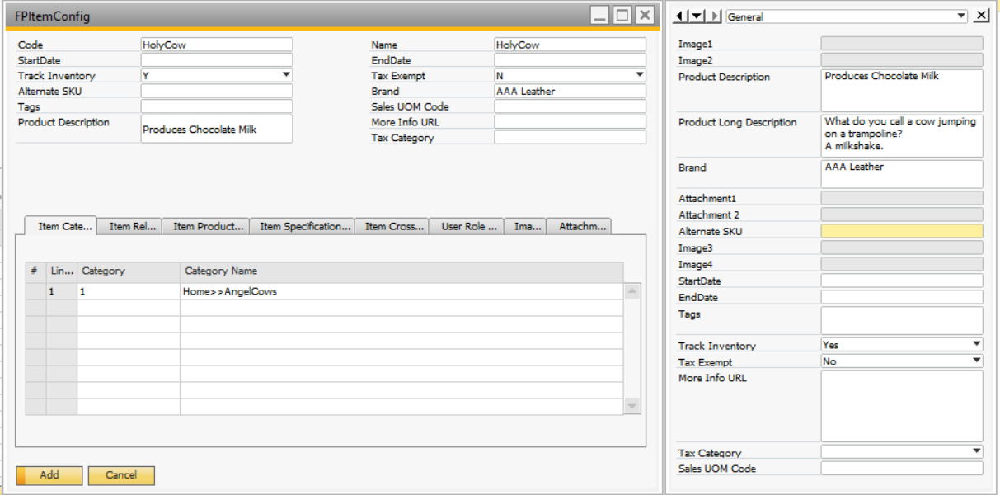

Item master with FP Item Config
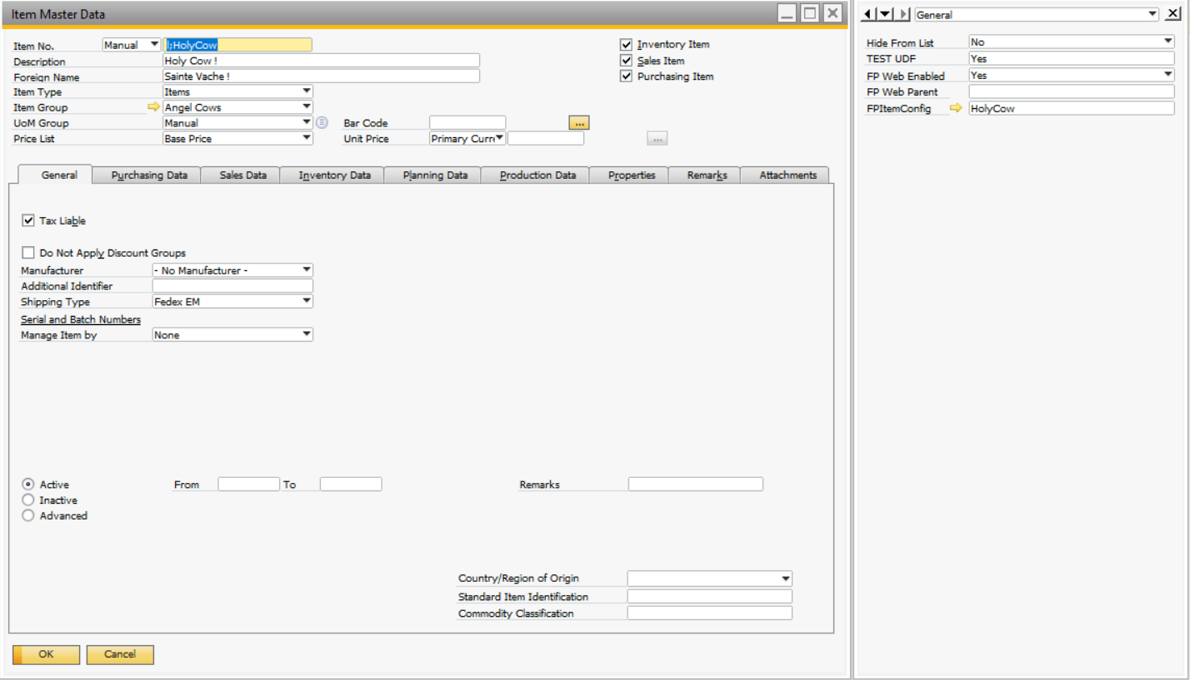
Contact/FP enabled user.
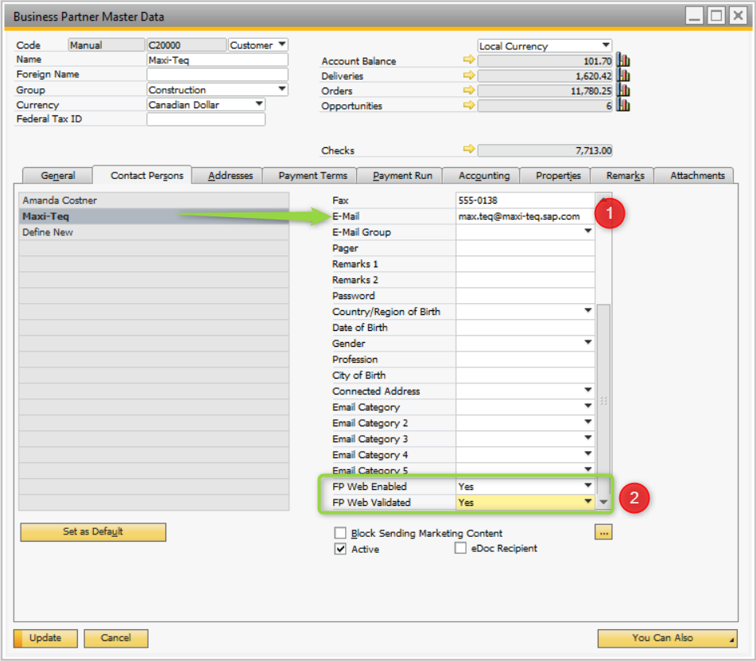

For: Customer For: Focused Impressions

Signature Signature

Printed Name Printed Name

Title Title


Date Date

