FocusPoint SLSync Integration Service Provisioning Process

1. Introduction
This document outlines each party’s responsibilities for provisioning SLSync Integration Service, FocusPoint’s background synchronization service that connects SAP Business One and your website.

2. Responsibilities

2.1 FocusPoint Responsibilities
- Provide whitelist IP
Supply the source IP address that must be whitelisted.
- Install and configure SLSync Integration Service
Perform installation and initial setup once all prerequisites are met.
- Handover testing
Execute end-to-end tests and validate successful data synchronization.

2.2 Vision33 Cloud Responsibilities
- Provision server
Provision an application server in the public subnet for SLSync (using an AWS EC2 t3.medium instance as a reference for server specifications). (Refer to Figure 1)
- Enable RDP access
Grant RDP access to the designated server for troubleshooting and configuration of the SLSync Integration Service.
- Verify SAP B1 Service Layer
Confirm it is installed and accessible from the SLSync server.
- Install database client tools
Microsoft SQL Server Management Studio (SSMS) for SQL Server / SAP HANA Studio for SAP HANA
- Create Windows service account
Provide a Windows user account (non-expiring password) to run the SLSync Integration Service and grant it read access to the SAP B1 attachments and image folders.
- Configure network & firewall
Whitelist the provided Azure IP address for inbound TCP ports 8444 and 8445, opening them only for that IP on both Windows Firewall and any external network firewalls to allow SLSync traffic.
- Enable monitoring connectivity
Ensure outbound access to https://slsync.focuspointb1.com for status updates.

- Create database user
Grant these permissions on the SAP database:
  - CREATE PROCEDURE
  - EXECUTE PROCEDURE
  - ALTER PROCEDURE
  - SELECT
  - INSERT (UDTs only; no core tables)
  - UPDATE (UDTs only; no core tables)
  - DELETE (UDTs only; no core tables)
  - ALTER and SELECT on the SBO_SP_PostTransactionNotice procedure

2.3 Vision33 Consulting Responsibilities
- Provide SAP B1 user accounts
Create a dedicated SAP B1 user for each schema/database and assign one of the following licenses:
  - Indirect License (requires Superuser)
  - Professional License
These accounts will be utilized by the SLSync Integration Service to post-transaction data into SAP Business One.

2.4 Customer Responsibilities
- Approve commercials for an app server

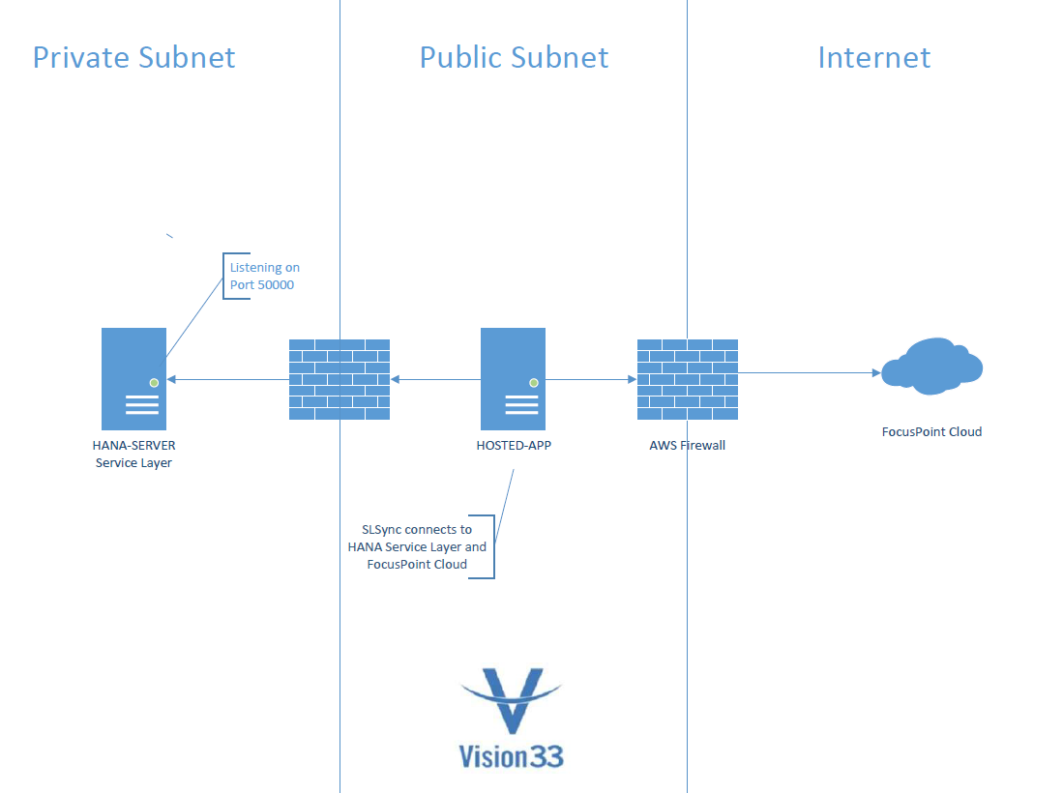
(Figure 1)

