FocusPoint SLSync Integration Service Provisioning Process
- Introduction
This document outlines each party’s responsibilities for provisioning SLSync Integration Service, FocusPoint’s background synchronization service that connects SAP Business One and your website.

Responsibilities

FocusPoint Responsibilities

Provide whitelist IP
Supply the source IP address that must be whitelisted.

Install and configure SLSync Integration Service
Perform installation and initial setup once all prerequisites are met.

Handover testing
Execute end-to-end tests and validate successful data synchronization.

Partner Responsibilities

Provision server
Provision an application server in the public subnet for SLSync (using an AWS EC2 t3.medium instance as a reference for server specifications). (Refer to Figure 1)

Enable RDP access
Grant RDP access to the designated server for troubleshooting and configuration of the SLSync Integration Service.

Verify SAP B1 Service Layer
Confirm it is installed and accessible from the SLSync server.

Install database client tools
Microsoft SQL Server Management Studio (SSMS) for SQL Server / SAP HANA Studio for SAP HANA

Create Windows service account
Provide a Windows user account (non-expiring password) to run the SLSync Integration Service and grant it read access to the SAP B1 attachments and image folders.

Configure network & firewall
Whitelist the provided Azure IP address for inbound TCP ports 8444 and 8445, opening them only for that IP on both Windows Firewall and any external network firewalls to allow SLSync traffic.

Enable monitoring connectivity
Ensure outbound access to https://slsync.focuspointb1.com for status updates.

Create database user
Grant these permissions on the SAP database:
      - CREATE PROCEDURE

      - EXECUTE PROCEDURE

      - ALTER PROCEDURE

      - SELECT

      - INSERT (UDTs only; no core tables)
      - UPDATE (UDTs only; no core tables)
      - DELETE (UDTs only; no core tables)
      - ALTER and SELECT on the SBO_SP_PostTransactionNotice procedure

Partner Consulting Responsibilities

Provide SAP B1 user accounts
Create a dedicated SAP B1 user for each schema/database and assign one of the following licenses:
      - Indirect License (requires Superuser)

Professional License
These accounts will be utilized by the SLSync Integration Service to post-transaction data into SAP Business One.

Customer Responsibilities
    - Approve commercials for an app server

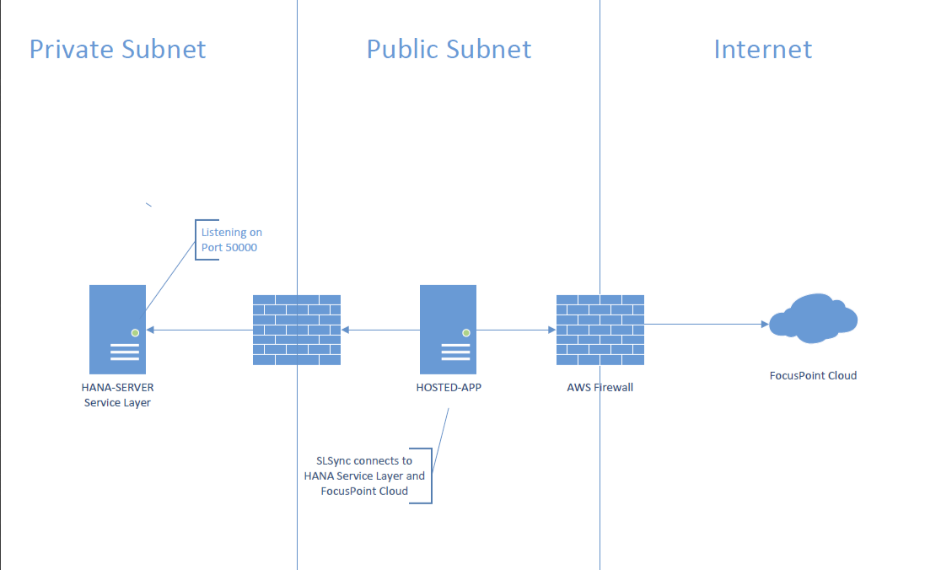

SLSync Provision Details
What is your SAP Version
10 | ☐
9.3 | ☐
9.2 | ☐
What is the database type:
Hana | ☐
SQL | ☐
How to access your server
*(VPN, Whitelist FP server RDP direct access, RDP gateway, Microsoft Gateway … etc.)
VPN | ☐
Whitelist FP Server | ☐
RDP Direct Access | ☐
RDP Gateway | ☐
Microsoft Gateway | ☐
Other | ☐
If Other, please provide details:
IF VPN Please provide VPN login details:
VPN technology:
VPN Server (if applicable):
Username:
Password:
Domain (if applicable):
Additional VPN info:
If not VPN, please provide access details as required:
Remote Desktop
IP:
User:
Password:
Must have access to the SAP B1 Share (Attachment Folder) Admin Account: Able to create, stop/start Windows services
SAP Client Server
IP:
User:
Password:
Must be installed on the same server or provide another server details where SAP B1 client is installed:
SAP Details
Username:
Password:
Ensure the SAP user is created with the same password on the company's test and production.
Test Company Name:
Production Company Name:
Service Layer URL:
By default, running on port 50000
*On Hana, it is installed by default on the Hana Linux server
*On SQL, it is installed by default on the SAP server

DB (SQL, Hana) User
Username:
Password:
Make sure the DB user is created with the same password and authorizations on both the company's test and prod and is set never to expire.
External connection IP/DNS name:
(to be able to access this from the website)
- Open Port 8444 *(whitelist the integration port 8444 to be accessible from the website).
- Website IP Enter here

